ConvLSTM2D keras实现
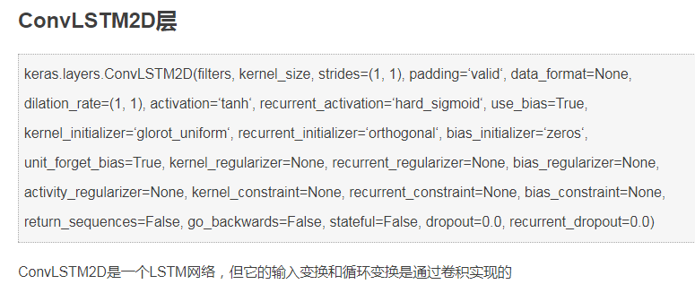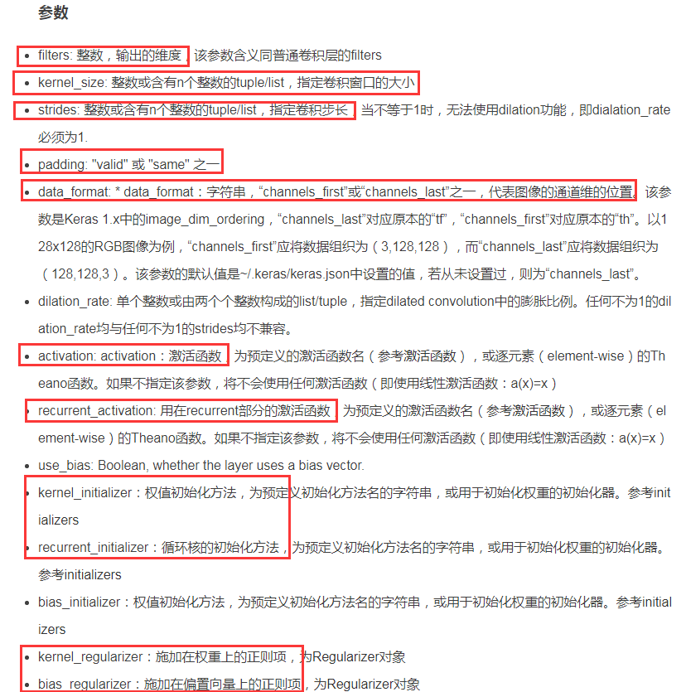
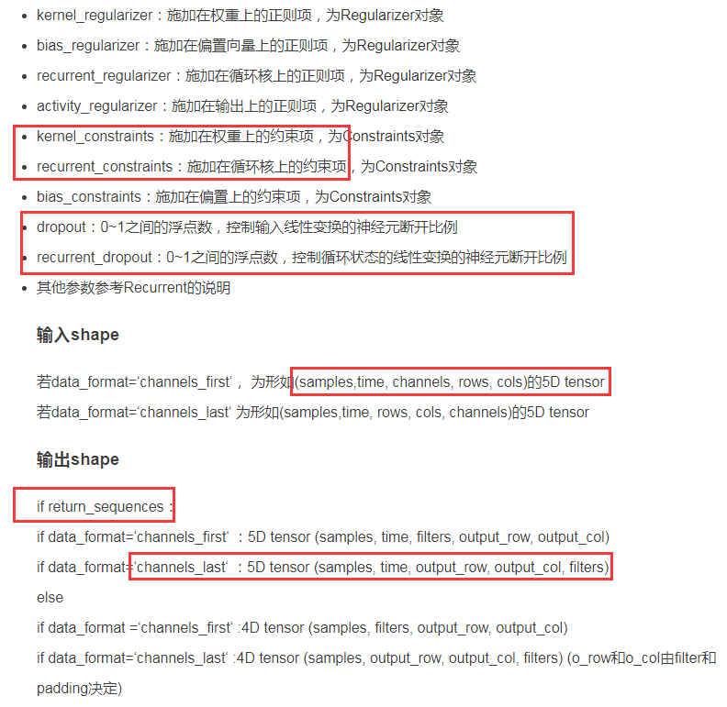
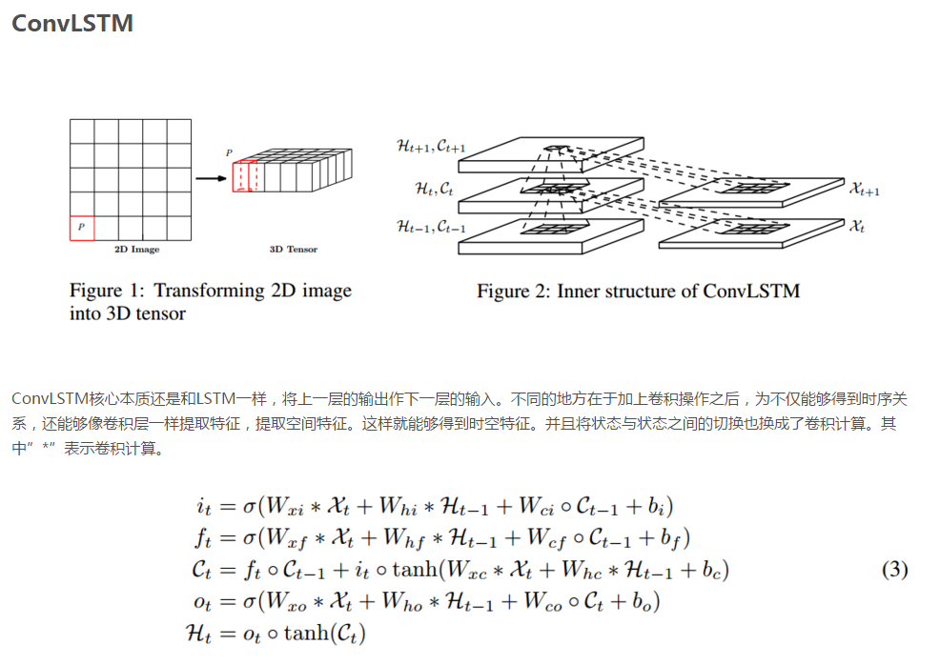

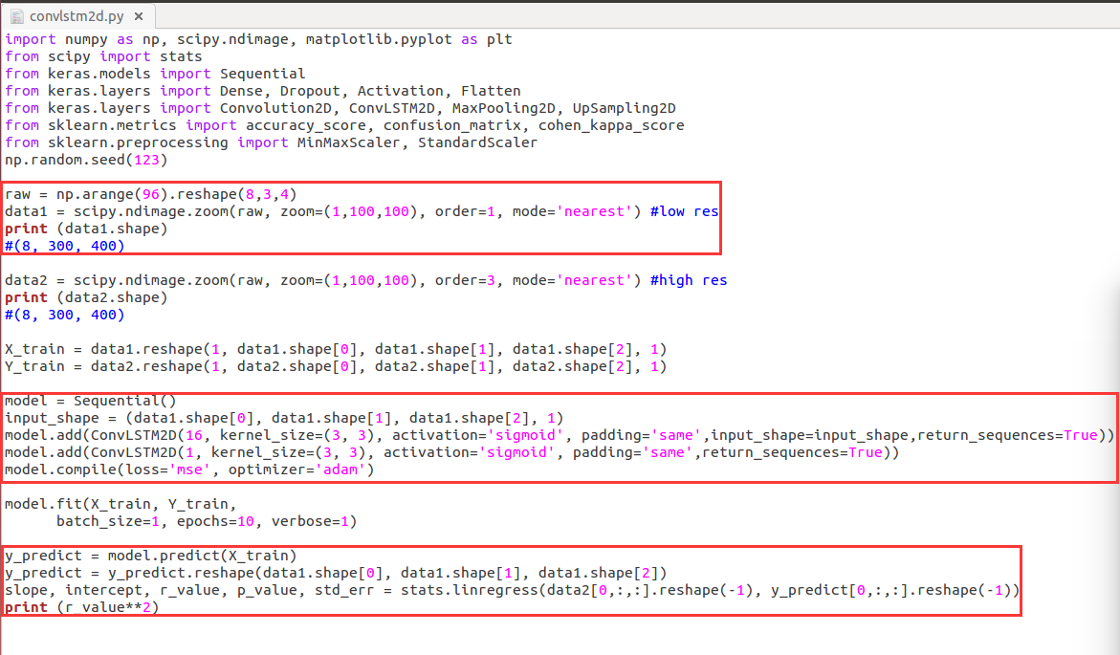

scipy.ndimage.zoom上采样与下采样
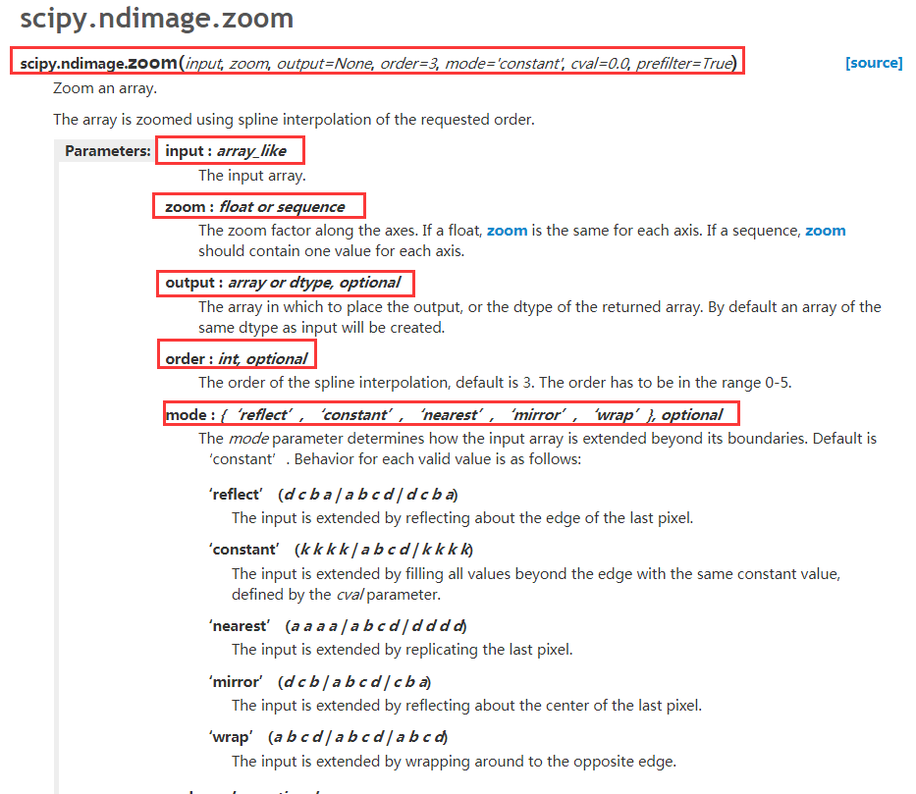
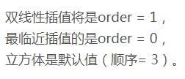
一个参数为-1时，那么reshape函数会根据另一个参数的维度计算出数组的另外一个shape属性值。
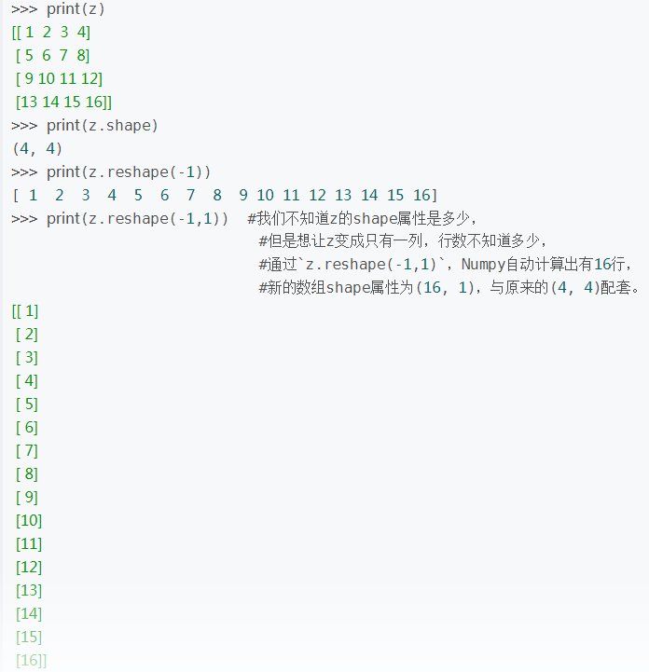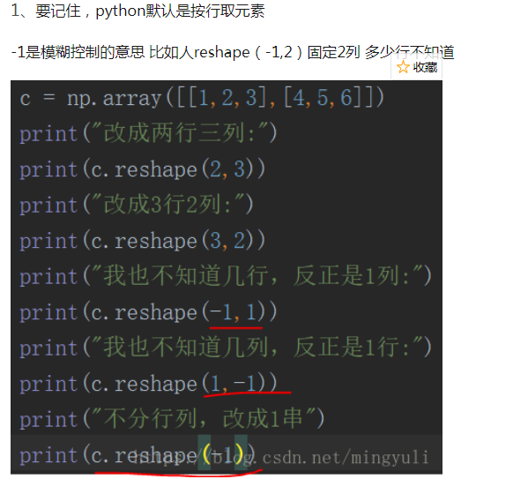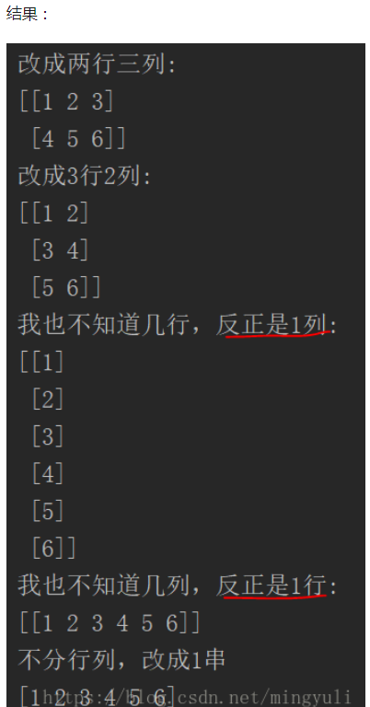
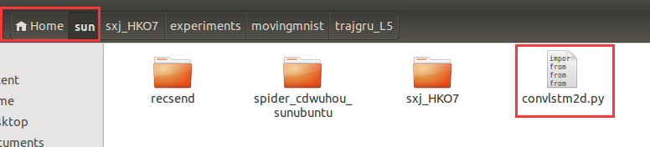
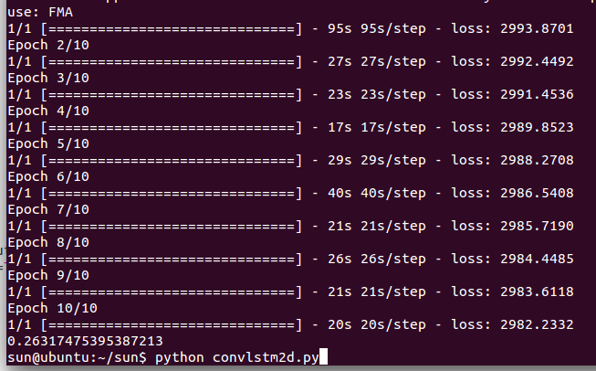

参考：
https://blog.csdn.net/luoganttcc/article/details/83539371
https://blog.csdn.net/gzj_1101/article/details/79586579
https://tensorflow.google.cn/api_docs/python/tf/keras/layers/ConvLSTM2D
http://www.mamicode.com/info-detail-2217844.html
https://blog.csdn.net/mingyuli/article/details/81040661

